**3D Printer Material**

Project Report Submitted by

**Mohd Tabish Nehal**

At

SmartBridge Educational Services Pvt. Ltd.

Hyderabad.

**Chapter 1**

* 1. **Introduction**
     1. **Python**

Python is a widely used general-purpose, high level programming language.

It was initially designed by Guido van Rossum in 1991 and developed by Python

Software Foundation. It was mainly developed for emphasis on code readability,

And its syntax allows programmers to express concepts in fewer lines of code.

* + 1. **Machine Learning**

Machine learning is a sub field of artificial intelligence (AI). The goal of machine learning generally is to understand the structure of data and fit that data into models that can be understood and utilized by people. Although machine learning is a field within computer science, it differs from traditional computational approaches. In traditional computing, algorithms are sets of explicitly programmed instructions used by computers to calculate or problem solve. Machine learning algorithms instead allow for computers to train on data inputs and use statistical analysis in order to output values that fall within a specific range. Because of this, machine learning facilitates computers in building models from sample data in order to automate decision-making processes based on data inputs.

Machine learning is a continuously developing field. Any technology user today has benefited from machine learning. Facial recognition technology allows social media platforms to help users tag and share photos of friends. Optical character recognition (OCR) technology converts images of text into movable type.

Recommendation engines, powered by machine learning, suggest what movies or television shows to watch next based on user preferences. Self-driving cars that rely on machine learning to navigate may soon be available to consumers.

* 1. **Objective**

The aim is to study how much of the adjustment parameters in 3d printers affect the print quality, accuracy and strength and develop a machine learning model which predicts the type of material used in printing.

* 1. **Problem Statement**

Work on the 3D Printer Material data-set and develop a machine learning model which could predict that what material has been used for printing. Integrate the model to IBM Watson Studio and deploy the model to Node-Red Starter.

**Chapter 2**

**Data Collection and Review of Literature**

**2.1 Review of Literature [1]**

3D printing was known as “rapid prototyping”. Chuck Hull, of 3D Systems Corporation, created the first working 3D printer in 1984. Later in the 80’s, Selective Laser Sintering (SLS) technology was developed by Dr. Deckard at the University of Texas at Austin during a project sponsored by Defense Advanced Research Projects Agency (DARPA). In the 1990s, the technology was further improved with the development of a method that used ultraviolet light to solidify photopolymer, a viscous liquid material.

In the late 20th century, 3D printers were extremely expensive and could only be used to print a limited number of products. The majority of the printers were owned by scientists and electronics enthusiasts for research and display. Although it was still in limited development, the printing technology was a combination of modeling both science and construction technology, using some of the newest technological advancements of the time. Consequently, 3D printing began to lead a worldwide manufacturing revolution.

In the past, surface design was mainly dependent on the production process. However developments in the field of 3D printing have allowed for the design of products to no longer be limited by complex shapes or colors

**2.2 Data Collection**

Dataset for the model has been obtained from the research and the research was done by the TR/Selcuk University Mechanical Engineering department.

**Chapter 3**

**Methodology**

**3.1 Exploratory Data Analysis**

Exploratory Data Analysis (EDA) is an approach to analyzing data sets to summarize their main characteristics, often with visual methods. A statistical model can be used or not, but primarily EDA is for seeing what the data can tell us beyond the formal modeling or hypothesis testing task.

**3.1.1 Figures and Tables**

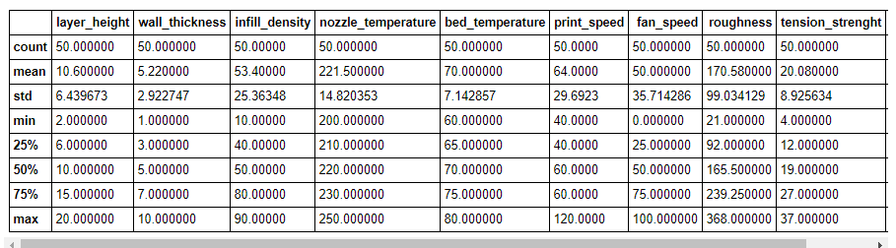

Figure 3.1: Describe

Count gives the count of observation present in the dataset. Mean finds the mean of the data present in the column. Std is the standard deviation for each column. 25% means that 25% data of the particular column are having these values like 25% data of layer height column are having value 6.

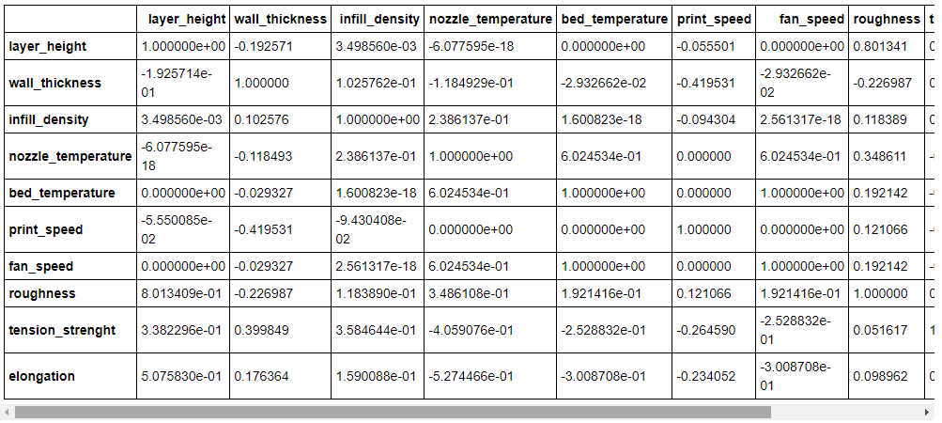

Figure 3.2: Correlation

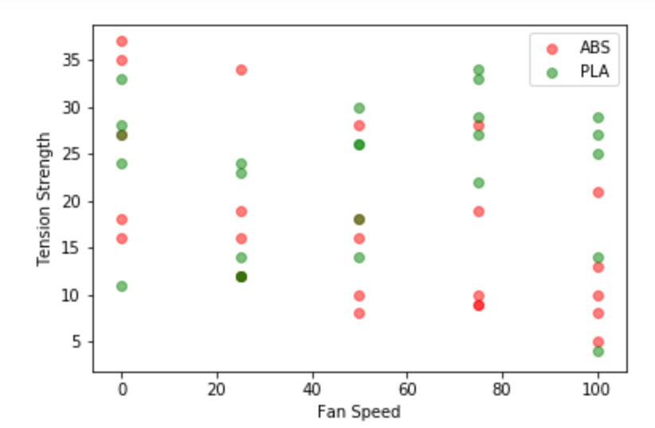

Figure 3.3: Effect of Fan Speed on Tension Strength

As We can observe, as the fan speed increases, Tension (Strength) for ABS decreases. So air circulation is not good for ABS.

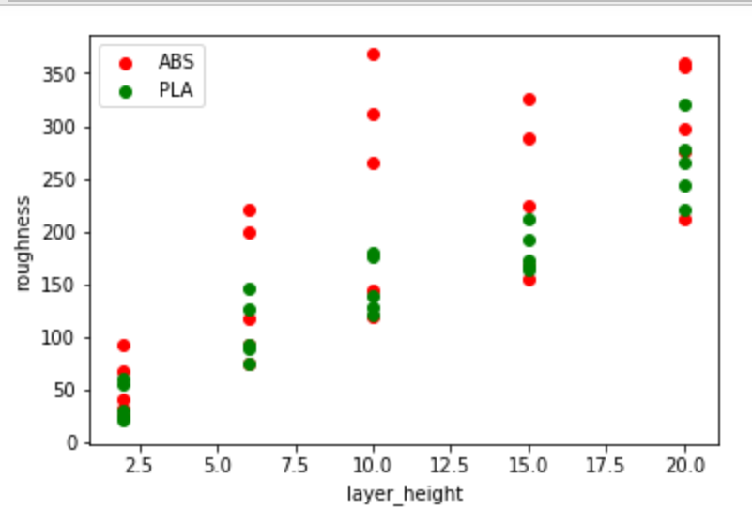

Figure 3.4: Effect of Layer Height on Roughness

As the layer height increases, roughness increases but PLA increases smoother

Than ABS

**3.2 Data Modeling**

Different Machine Learning Technique has been applied on the 3D Printer Material

Dataset –

•k nearest Neighbors

•Support Vector Classification

•Decision Tree Classifier

•Random Forest Classifier

**3.3 Implementation**

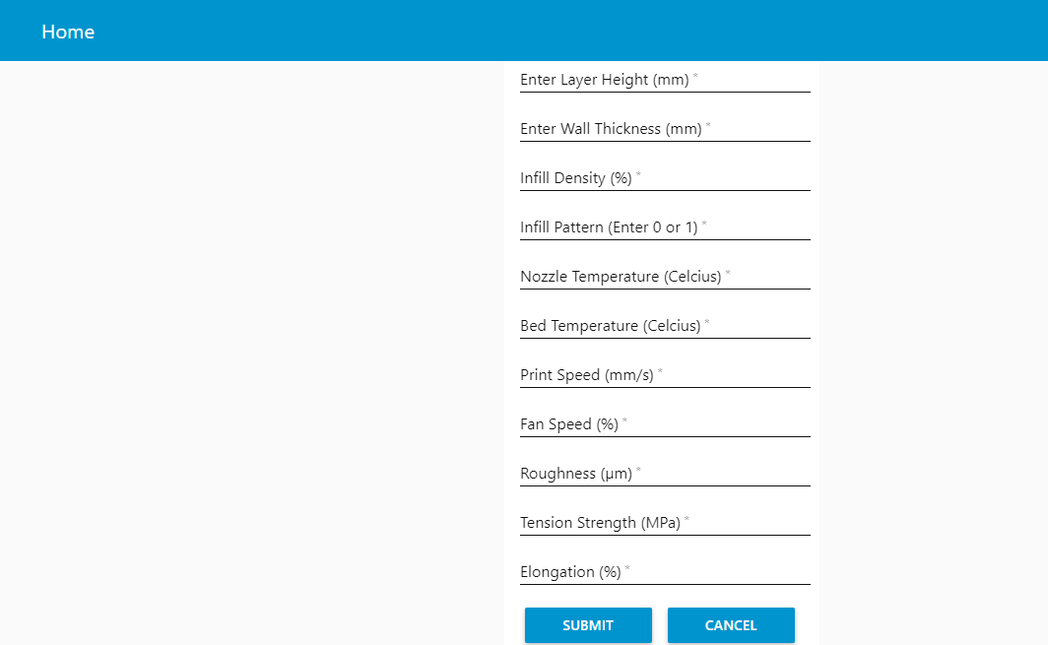

Figure 3.5: User Interface

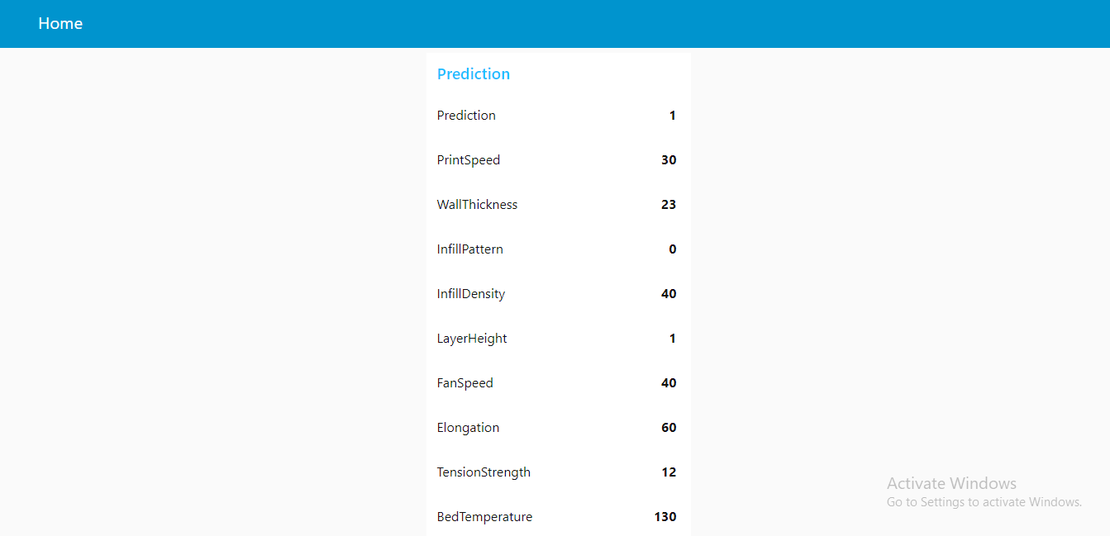

Figure 3.6: Prediction

**Chapter 4**

**4.1 Conclusion**

* Air circulation is not good for ABS material
* Roughness increases as the layer height increases
* As we decrease the percentage of test data, we are getting 100 % accuracy with some technique due to small number of observation in the test data.
* Random Forest Classifier is producing high value of accuracy, Recall and ROC score.

Accuracy score: 93.333333

Recall score: 88.888889

ROC score: 94.444444

* Decision Tree Classifier is producing high AUC score

AUC Score (Decision Tree Classifier): 0.82

**4.2 References**

**[1]** “Infographic: A brief History of 3D Printing," Troweprice, [Online]. Available: http://individual.troweprice.com/public/Retail/Planning-&-R research/Connections/3D-Printing/Infographic.